Exploratory Data Analysis Using SQL

Introduction
This project focuses on analyzing customer, order, product, and shop data using SQL. The purpose of the analysis is to understand sales performance, customer purchasing behavior, product demand, shop performance, revenue distribution, and other important business patterns.
The database used in this project contains four main tables: customers, orders, products, and shops. Different SQL queries were used to answer business-related questions and generate meaningful insights from the available data.

Objectives
The main objectives of this analysis are:
- To analyze customer purchasing behavior and spending.
- To identify high-performing customers, products, and shops.
- To study revenue and sales patterns.
- To identify products that are not being ordered.
- To understand customer loyalty and ordering behavior.
- To compare shop performance across different locations and categories.
- To generate a detailed customer summary for business analysis.

Exploratory Data Analysis

Q1. Top 3 Highest Spending Customers

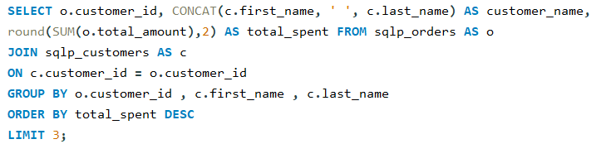
Purpose:
This analysis identifies the customers who have spent the highest amount on their orders. It helps the business recognize its most valuable customers.

Q2. Best-Selling Product in Each Category

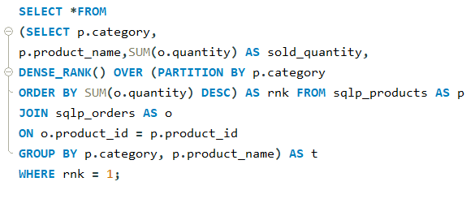
Purpose:
This analysis identifies the most popular product within every product category. It helps understand which products perform best in different categories.

Q3. Customers Who Never Placed an Order

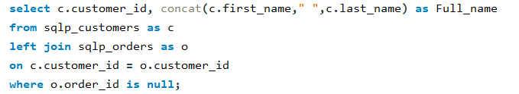
Purpose:
This analysis identifies registered customers who have not placed any orders. This can help the business target inactive customers with offers or promotions.

Q4. Month-over-Month Revenue Growth for 2024

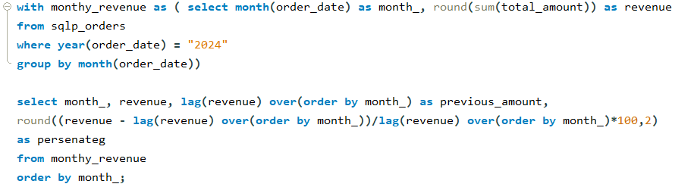
Purpose:
This analysis is intended to measure how revenue changes from one month to another during 2024. It can help identify periods of business growth or decline.

Q5. Percentage of Cancelled or Returned Orders by Shop

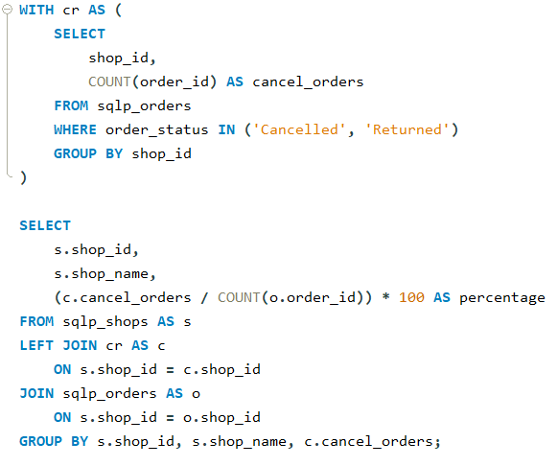
Purpose:
This analysis measures the percentage of cancelled and returned orders for each shop. It helps identify shops that may have higher order-related problems.

Q6. Customers Ordering from Multiple Shops

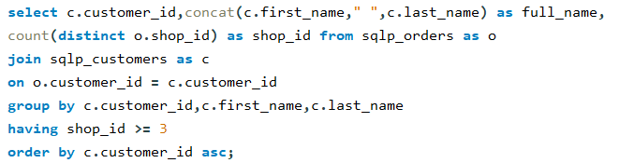
Purpose:
This analysis identifies customers who have ordered from multiple shops. It helps understand customers with broader purchasing activity across the available shops.

Q7. Second Highest Order Amount for Each Customer

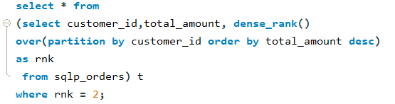
Purpose:
This analysis finds the second highest order value placed by each customer. It helps compare customers' higher-value purchases while excluding customers with only one order.

Q8. Running Total Revenue per Shop

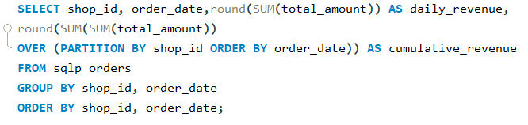
Purpose:
This analysis is intended to track how total revenue accumulates over time for each shop. It can help observe the revenue growth pattern of individual shops.

Q9. Products That Have Never Been Ordered

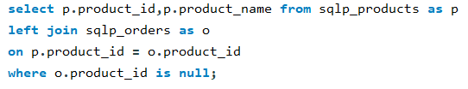
Purpose:
This analysis identifies products that have not received any orders. This can help the business review products with low or no customer demand.

Q10. Average Order Value by Loyalty Tier

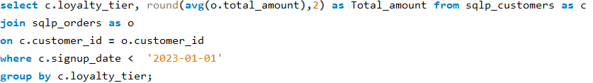
Purpose:
This analysis compares the average order value across different customer loyalty tiers. Only customers who signed up before the specified date are included in the analysis.

Q11. Time Taken by Customers to Place Their First Order

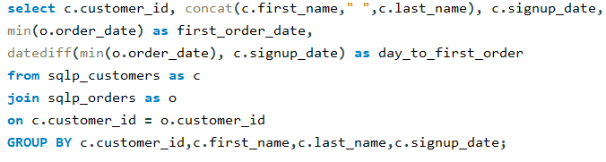
Purpose:
This analysis measures the number of days between customer signup and their first order. It helps understand how quickly customers start purchasing after registration.

Q12. Classification of Orders by Value

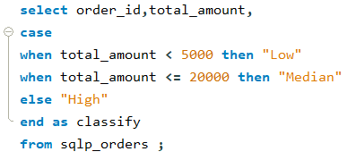
Purpose:
This analysis is intended to divide orders into different value groups and count how many orders fall into each group by year. It helps understand the distribution of low, medium, and high-value orders.

Q13. Top-Performing Shop in Each State

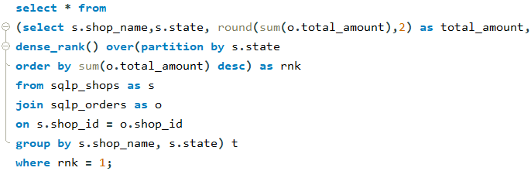
Purpose:
This analysis identifies the shop with the highest revenue in each state. It helps compare shop performance within different geographical locations.

Q14. Customers Spending Above the Average

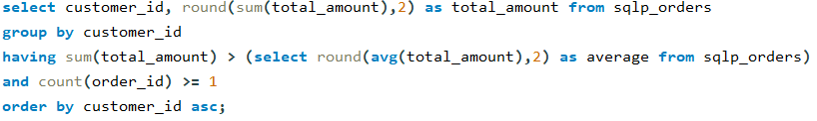
Purpose:
This analysis identifies customers whose total spending is higher than the average amount calculated from the order data. It helps recognize higher-value customers.

Q15. Highest and Lowest Performing Shops by Shop Type

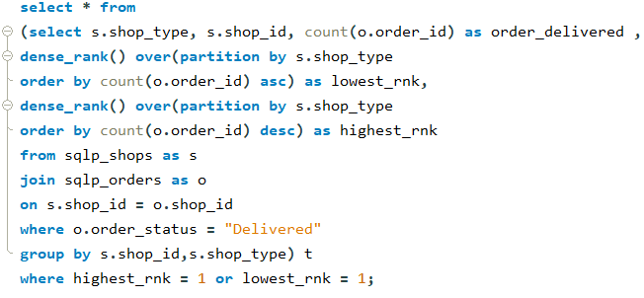
Purpose:
This analysis identifies the shops with the highest and lowest number of delivered orders within each shop type. It helps compare performance among similar types of shops.

Q16. Customers Placing Multiple Orders on the Same Date

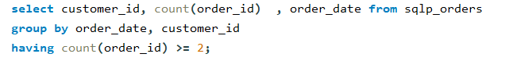
Purpose:
This analysis identifies customers who placed more than one order on the same date. It helps detect repeated or batch purchasing activity.

Q17. Three-Month Moving Average of Orders

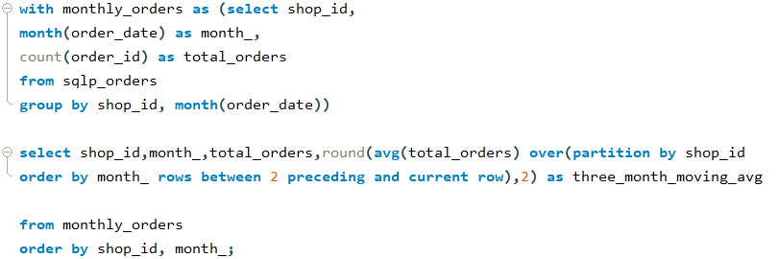
Purpose:
This analysis is intended to calculate the average number of orders over a three-month period for each shop. It helps smooth short-term changes and observe overall ordering patterns.

Q18. Revenue Contribution by Product Category

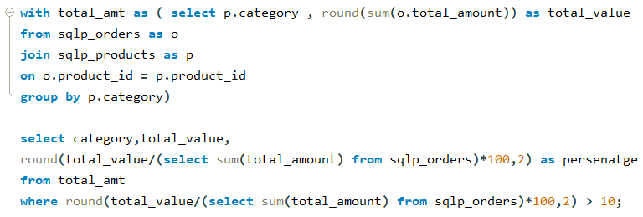
Purpose:
This analysis calculates how much each product category contributes to the company's total revenue. It focuses on categories that contribute more than 10 percent of total revenue.

Q19. Customers Who Purchased from Every Category

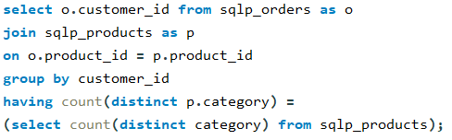
Purpose:
This analysis identifies customers who have purchased products from every available category. It helps recognize customers with very broad purchasing behavior.

Q20. Busiest Day of the Week for Each Shop

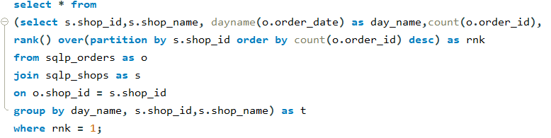
Purpose:
This analysis identifies the day of the week when each shop receives the highest number of orders. It can help understand peak business days for different shops.

Q21. Longest Gap between Customer Orders

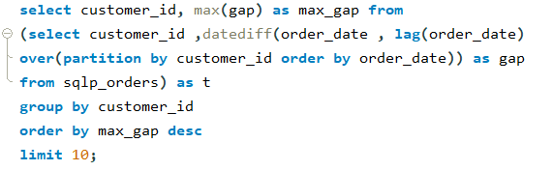
Purpose:
This analysis measures the longest number of days between consecutive orders for customers. It helps identify customers who had long gaps between purchases.

Q22. Overall and State-Level Revenue Ranking of Shops

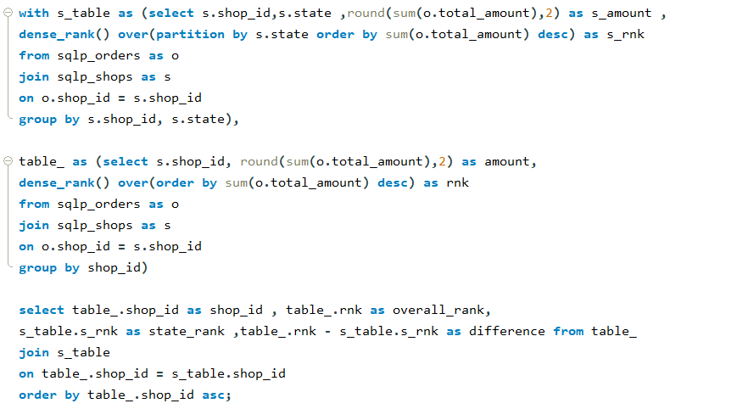
Purpose:
This analysis compares the revenue ranking of each shop at the overall level and within its respective state. It helps understand how a shop performs locally compared with its overall position.

Q23. Complete Customer Summary Report

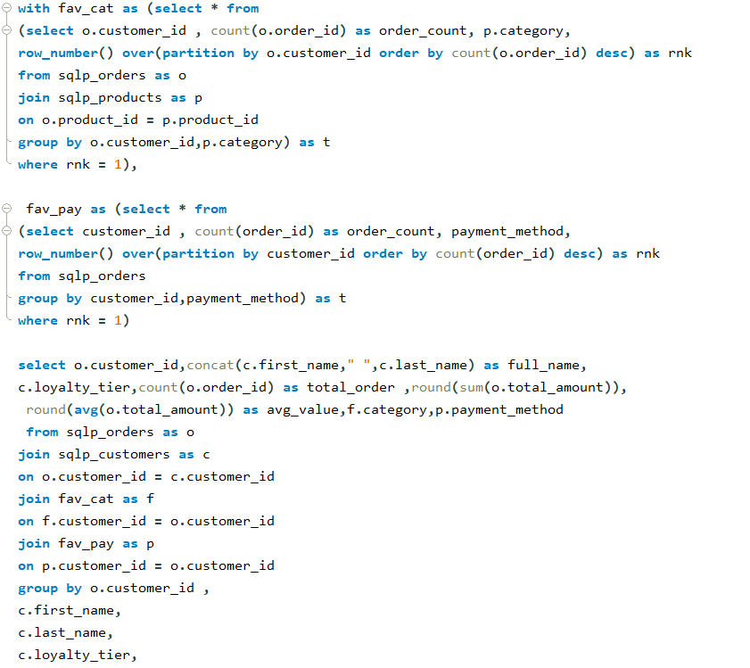
Purpose:
This analysis creates a detailed summary of each customer, including their name, loyalty tier, number of orders, total spending, average order value, preferred category, and most-used payment method. It provides a complete overview of customer purchasing behavior.

Key Findings
The SQL analysis provides useful information about different aspects of the business. The analysis helps identify high-spending customers, best-selling products, inactive customers, top-performing shops, and important revenue patterns.
It also provides insights into customer purchasing behavior, loyalty tiers, product preferences, payment methods, and order frequency. Shop-level analysis helps compare performance across different shop types and states.
The analysis can support better business decisions by identifying strong-performing areas as well as products, customers, or shops that may require additional attention.

Conclusion
This Exploratory Data Analysis project shows that the business generates strong overall revenue (₹6.78 crore across 800 orders), with ₹4.21 crore (62%) coming from Delivered orders alone. However, nearly 17% of orders are Cancelled or Returned, with three shops — Nagpur Plaza (30.4%), Lucknow Central (29.1%), and Kochi Square (21.9%) — driving a disproportionate share of these problem orders. Beauty (22.3%), Electronics (21.9%), and Fashion (19.8%) are clearly the revenue engines of the business, together contributing close to two-thirds of total sales, while categories like Sports (3.4%) and Home & Kitchen (5%) remain underperforming and may benefit from targeted promotions. Best-selling products such as Nivea Face Wash and Nike Running Shoes (80 units each) confirm that Beauty and Fashion also lead in unit demand, not just revenue.
Customer analysis reveals a small set of high-value customers (led by Curtis Smith at ₹10.48 lakh and David Allen at ₹10.21 lakh) who anchor a large share of revenue, alongside a broader base of 100 out of 120 customers (83%) who shop across more than 3 different outlets rather than staying loyal to one. However, no customer purchases across all 8 product categories, and some customers have gone over 900 days without ordering again — pointing to real opportunities in cross-selling and win-back campaigns. Gold-tier customers show the highest average order value (₹95,532), narrowly ahead of Platinum (₹94,064), suggesting loyalty tier alone doesn't fully predict spending behavior. Online Hub emerges as the best-performing shop format, generating ₹2.82 crore in revenue from 333 orders — well ahead of Franchise Outlets and Flagship Stores — while Pop-up Stores lag far behind at just ₹38.6 lakh, suggesting the business's digital channel is outperforming physical formats and may deserve further investment.
Overall, the analysis demonstrates how SQL-driven exploration can convert raw transactional data into concrete, actionable business insights — identifying where revenue is concentrated, where operational issues (cancellations/returns) are hurting performance, which customer segments and shop formats drive the most value, and where growth opportunities (cross-category selling, shop-level fixes, seasonal promotions, and win-back campaigns) exist to strengthen the business going forward.

